
Lab 01: Introduction to Measurement and Error Analysis

Students Name:

Abdullah Anwar
Shaheer Ahmad Mirza
Fahad Amir
Fahad Hassan
Rameen Arjmand
Abeera Ahsan
Hania Nauman
Group Number: 7
Class: BESE-17A
School: School of Electrical Engineering and Computer Science (SEECS)
Date: September 16, 2026

Lab 01: Introduction to Measurement and Error Analysis

Abstract:
These three experiments were performed in order to understand the principles of measurement and error analysis using a real object (laptop), a meter rule, an iron stand, a piece of string, a metallic bob and a vernier caliper. In the first and second experiments, the length and width were measured to compute the perimeter and area of the object, along with their standard errors. In the third experiment, the gravitational acceleration was determined, along with the standard error in it. All the calculations in these experiments were performed using a python program.

EXPERIMENT # 1 and 2
Calculate the standard error in the area and perimeter of a real object.
Apparatus:
- Real Object (laptop)
- Meter Rule

Procedure:
- The length and width of the object were measured and recorded five times using a meter rule by each group member.
- On the computer, a Python program was run to calculate the mean values and standard errors in the recorded data.
- One Python codes were written and run to calculate the final perimeter and area of the object, along with the standard errors in them.

Data:
Sr. No | Length l (cm) | Width w (cm)
1 | 32.5 | 22.7
2 | 32.5 | 22.8
3 | 32.6 | 22.6
4 | 32.7 | 22.8
5 | 32.6 | 22.7

Calculations:
- Mean Value = sum of all values/number of all values
$\frac{l_{1+}l_{2+}l_{3+}l_{4+}l_{5}}{5}$ = $l_{mean}$= 32.58 cm

mean_value_length = numpy.mean(length)
print("\nLength:\n")
print("Mean Length is: " + str(mean_value_length))

$\frac{w_{1+}w_{2+}w_{3+}w_{4+}w_{5}}{5}$ = $w_{mean}$= 22.72 cm
mean_value_width = numpy.mean(width)
print("\n\nWidth:\n")
print("Mean Width is: " + str(mean_value_width))

- Mean Deviation
$\frac{{Δl}_{1+}Δl_{2+}{Δl}_{3+}{Δl}_{4+}Δl_{5}}{5}$, where Δ$l_{1}$ = $\left|l_{mean}-l_{1}\right|$ = 0.064 cm
$\frac{{Δw}_{1+}Δw_{2+}{Δw}_{3+}{Δw}_{4+}Δw_{5}}{5}$, where Δ$w_{1}$ = $|w_{mean}-w_{1}|$ = 0.064 cm

- Standard Deviation
S_{l}=$\sqrt{\frac{{{(l}_{1}-l_{mean})}^{2}+{{(l}_{2}-l_{mean})}^{2}+{{(l}_{3}-l_{mean})}^{2}+{{(l}_{4}-l_{mean})}^{2}+{{(l}_{5}-l_{mean})}^{2}}{(N-1)}}$= 0.0837

standard_deviation_length = numpy.std(length, ddof = 1)
print("Standard Deviation in Length is: " + str(round(standard_deviation_length, 4)))

S_{w}=$\sqrt{\frac{{{(w}_{1}-w_{mean})}^{2}+{{(w}_{2}-w_{mean})}^{2}+{{(w}_{3}-w_{mean})}^{2}+{{(w}_{4}-w_{mean})}^{2}+{{(w}_{5}-w_{mean})}^{2}}{(N-1)}}$= 0.0837

standard_deviation_width = numpy.std(width, ddof = 1)
print("Standard Deviation in Width is: " + str(round(standard_deviation_width, 4)))

- Degree of freedom = 4

- Standard-Error:
$σ_{l}=\frac{S_{l}}{\sqrt{N}}$ = 0.0374
standard_error_length = standard_deviation_length/numpy.sqrt(len(length))
print("Standard Error in Length is: " + str(round(standard_error_length, 4)))

$σ_{w}=\frac{S_{w}}{\sqrt{N}}$ = 0.0374

standard_error_width = standard_deviation_width/numpy.sqrt(len(width))
print("Standard Error in Width is: " + str(round(standard_error_width, 4)))

- F = l + w (for perimeter) | - F = l x w
$$σ_{f}=2\sqrt{σ_{l}^{2}+σ_{w}^{2}}$$ | $$σ_{f}=\sqrt{l^{2}σ_{w}^{2}+w^{2}σ_{l}^{2}}$$
where σ means standard error
Analyses:
 | Length (l) | Width (w)
Degree of Freedom | 4 | 4
Mean Value | 32.58 | 22.72
Standard Deviation | 0.0837 | 0.0837
Standard Error | 0.0374 | 0.0374

The perimeter of the object (rectangular) = 2(l + w) = (110.6 ± 0.1058) cm

Perimeter = 2*(mean_value_length + mean_value_width)
standard_errorperimeter = numpy.sqrt((pow(standard_error_length, 2)+ pow(standard_error_width, 2)))
print("\nThe Perimeter is: " + str(Perimeter) + " ± " + str(round(standard_errorperimeter, 4)))

The area of the object (rectangular) = l x w = (740.2176 ± 1.4862) cm²
Area = mean_value_length * mean_value_width
standard_errorarea = numpy.sqrt((pow(standard_error_length, 2) * pow(mean_value_width, 2)) + (pow(standard_error_width, 2) * pow(mean_value_length, 2)))
print("\nThe Area is: " + str(Area) + " ± " + str(round((standard_errorarea), 4)))

Discussion:

The relative uncertainty in the Area is much larger compared to the Perimeter. This is because multiplying length and width compounds their fractional uncertainty, whereas Perimeter involves addition (error propagation of absolute error instead of fractional error).

Because the combined percentage error of length and width is going to be multiplied by the Area to calculate actual absolute error of Area ∆A, the large object dimensions magnify error value as:

$$∆A=Area ×Combined fractional Error$$

Or in calculus it can be approximated as:

$$∆A≈ \sqrt{(w.∆l)^{2}+(l.∆w)^{2}}$$

During these experiments, various precautions were taken to reduce the errors; however, complete elimination of error is never possible due to the limitations in the experimental values.
Sources of Error:
- Parallax error
- Improper calibration of instruments

Precaution:
- Align the line of sight perpendicular to the ruler .
- Verify the zero-markings of the ruler against a known standard to prevent systematic error.

Conclusion:
In this experiment, we understood the principles of measurement and error analysis. This experiment was able to show the physical application of error propagation. The experiment also explored python as a tool to calculate our data.
The results contain 0.1058cm propagated error for the perimeter and 1.4862 cm² for the area of the object. The final values came out to be (110.6 ± 0.1058) cm and (740.2176 ±1.4862) cm² for the perimeter and area of the object, respectively.

OUTPUT OF THE CODE

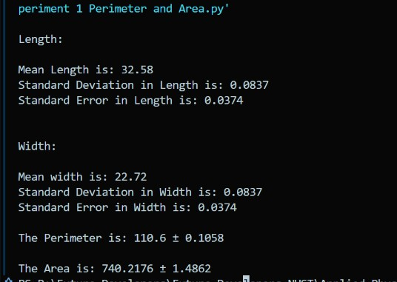
EXPERIMENT # 3
Determine the gravitational acceleration of Earth and the standard error in it.
Apparatus:
- Meter Rule
- Iron Stand
- Piece of string
- Metallic Bob
- Vernier Caliper
Procedure:
- The length of the string and the radius of the bob were measured and recorded three times using a meter rule and a vernier caliper respectively by each group member.
- On the computer, a Python program was run to calculate the mean values and standard errors in the recorded data.
- A Python code was written and run to calculate the final gravitational acceleration and the standard error in it.
Data:
Sr. No | Total Length of Pendulum L (cm) |  | Total Time (s)  of 20 vibrations | Time Period T (s)
Sr. No | length of the string (l) | Radius of the bob (r) | Total Time (s)  of 20 vibrations | Time Period T (s)
1) | 36.4 | 0.62125 | 23.91 | 1.1955
2) | 36.3 | 0.6025 | 23.98 | 1.199
3) | 36.4 | 0.615 | 24.19 | 1.2095

Calculations:
- Mean Value = sum of all values/number of all values
- $\frac{l_{1}+ l_{2}+ l_{3}}{3}= l_{mean}=36.3667$cm
mean_length_of_string = numpy.mean(lengths_of_string)
print("\nThe Mean Length of the String is: " + str(round(mean_length_of_string, 4)) + " cm")
- $\frac{r_{1}+ r_{2}+ r_{3}}{3}= r_{mean}=0.6129$cm
mean_radius_of_bob = numpymean(radii_of_bob)
print("\nThe Mean Radius of the Bob is: " + str(round(mean_radius_of_bob, 4)) + " cm")

- $\frac{t_{1}+ t_{2}+ t_{3}}{3}= t_{mean}=1.2013$s
mean_time_period = numpy.mean(time_periods)
print("\nThe Mean Time Period is: " + str(round(mean_time_period, 4)) + " s")
- Total Length = $l_{mean}$ + $r_{mean}$ = 36.9796 cm

- Mean Déviation
$\frac{Δ l_{1}+ Δ l_{2}+ Δ l_{3}}{3}$, where $Δ l_{1}= \left|l_{mean}- l_{1}\right|$ = 0.05138 cm
$\frac{ΔT_{1}+ ΔT_{2}+ ΔT_{3}}{3},$where $Δ T_{1}= \left|T_{mean}- T_{1}\right|$ = 0.00543 s

- Standard Déviation
$$s_{l}=\sqrt{\frac{ {\left(l_{1}- l_{mean}\right)}^{2}+ {\left(l_{2}- l_{mean}\right)}^{2}+ {\left(l_{3}- l_{mean}\right)}^{2}}{N-1}}=0.0577 cm$$
$$s_{r}=\sqrt{\frac{ {\left(r_{1}- r_{mean}\right)}^{2}+ {\left(r_{2}- r_{mean}\right)}^{2}+ {\left(r_{3}- r_{mean}\right)}^{2}}{N-1}}=0.0095 cm$$
$$s_{T}=\sqrt{\frac{ {\left(T_{1}- T_{mean}\right)}^{2}+ {\left(T_{2}- T_{mean}\right)}^{2}+ {\left(T_{3}- T_{mean}\right)}^{2}}{N-1}}=0.0073 s$$

- Degree of freedom = 2
$\sqrt{\frac{∑{\left(Δl\right)}^{2}}{N-1}}=$0.0577
standard_deviation_length_of_string = numpy.std(lengths_of_string, ddof = 1)
print("The Standard Deviation is: " + str(round(standard_deviation_length_of_string, 4)))
$$\sqrt{\frac{∑{\left(Δr\right)}^{2}}{N-1}}= 0.0095$$
standard_deviation_radius_of_bob = numpy.std(radii_of_bob, ddof = 1)
print("The Standard Deviation in the Radius of the Bob is: " + str(round(standard_deviation_radius_of_bob, 4)))

$$\sqrt{\frac{∑{\left(ΔT\right)}^{2}}{N-1}}= 0.0073$$
standard_deviation_time_period = numpy.std(time_periods, ddof = 1)
print("The Standard Deviation in Time Period is: " + str(round(standard_deviation_time_period, 4)))

- Standard Error:
$$σ_{l}=\frac{s_{l}}{\sqrt{N}}= 0.0333 cm$$
standard_deviation_total_length_of_string= standard_error_total_length*numpy.sqrt(len(lengths_of_string))
print("The Standard Deviation in the Total length of the String is: " + str(round(standard_deviation_total_length_of_string, 4)))
$$σ_{r}=\frac{s_{r}}{\sqrt{N}}= 0.0055 cm$$
standard_deviation_radius_of_bob = numpy.std(radii_of_bob, ddof = 1)
print("The Standard Deviation in the Radius of the Bob is: " + str(round(standard_deviation_radius_of_bob, 4)))
$$σ_{T}=\frac{s_{T}}{\sqrt{N}}= 0.0042 cm$$
standard_deviation_time_period = numpy.std(time_periods, ddof = 1)
print("The Standard Deviation in Time Period is: " + str(round(standard_deviation_time_period, 4)))

- Addition of mean values of length and radius, along with their standard errors:
l + r = L = 36.3667 + 0.6129 = 36.9796 cm
total_length = mean_length_of_string + mean_radius_of_bob
$$σ_{L}= \sqrt{σ_{l}^{2}+ σ_{r}^{2}}= \sqrt{{(0.0333)}^{2}+ {\left(0.0055\right)}^{2}}= 0.03375 cm$$
standard_deviation_total_length_of_string= standard_error_total_length*numpy.sqrt(len(lengths_of_string))
print("The Standard Deviation in the Total length of the String is: " + str(round(standard_deviation_total_length_of_string, 4)))

$$g =\frac{4 π^{2}L}{T^{2}}$$
$$σ_{g}= 4 π^{2}\left(\frac{L}{T^{2}}\right)⋅\sqrt{{\left(\frac{ΔL}{L}\right)}^{2}+ {\left(\frac{2 ΔT}{T}\right)}^{2}}$$
Analyses:
 | Length (L) | Time Period (T)
Degree of Freedom | 2 | 2
Mean Value | 36.9796 | 1.2013
Standard Deviation | 0.0585 | 0.0073
Standard Error | 0.03375 | 0.0042

The length of the pendulum = L = (36.9796 ± 0.03375) cm
The Time period of the Pendulum = T = (1.2013 ± 0.0042) s
The standard error in T² = 0.0101 s²
standard_error_squared_time_period = 2*mean_time_period*standard_error_time_period
print("The Standard Error in the Square of the Time Period is: " + str(round(standard_error_squared_time_period, 4)))
The gravitational acceleration = g $=\frac{4 π^{2}L}{T^{2}}$= (1011.5671 ± 7.1441) cm/s²
gravitational_acceleration = 4*math.pi*math.pi*ratio_length_to_time_period_squared
The percentage error in gravitational acceleration = 0.7062%
percentage_error_gravitationalacceleration= (standard_error_gravitational_acceleration/gravitational_acceleration)*100
Discussion:
In this experiment, we determined the gravitational acceleration, along with the standard error in our calculation.
The calculated value 1011.5671 cm/s² has deviated from theoretical value 980.67 cm/s² by only 3.15 %.
This is because of random and human errors such as performing the experiment with our ceiling fans running the wind from which along with the air resistance affects the measurement of time period.
The low random errors, as percentage error is 0.7062% and standard error of T² is only 0.0101 s² , indicates that our measurements were highly precise.
During these experiments, various precautions were taken to reduce the errors; however, complete elimination of error is impossible due to the limitations in the experimental values.
Sources of Error:
- Human errors
- Parallax error
- Air friction
- Improper calibration of instruments
- Small angle approximation i.e. 10º
Precautions:
- Handle the apparatus carefully.
- Align the line of sight perpendicular to the ruler.
- Do not touch the pendulum once it is released to swing and switch the ceiling fan off.
- Verify the zero-markings of the ruler against a known standard to prevent systematic error.
- Keeping the pendulum extremes equal to or less than 10º from the mean position.
Conclusion:
The experiment explored the principles of measurement and the source of errors and was able to demonstrate a precise result.
The experiment also explored python as a tool to calculate our data.

The result contains 0.71441% percentage error in the gravitational acceleration of the earth. Our final value came out to be 1011.5671 cm/s² OR 10.11 m/s² for gravitational acceleration.
GROUP MEMBERS
- Abdullah Anwar 5. Rameen Arjmand
- Shaheer Mirza 6. Abeera Ahsan
- Fahad Hassan 7. Hania Nauman
- Fahad Amir

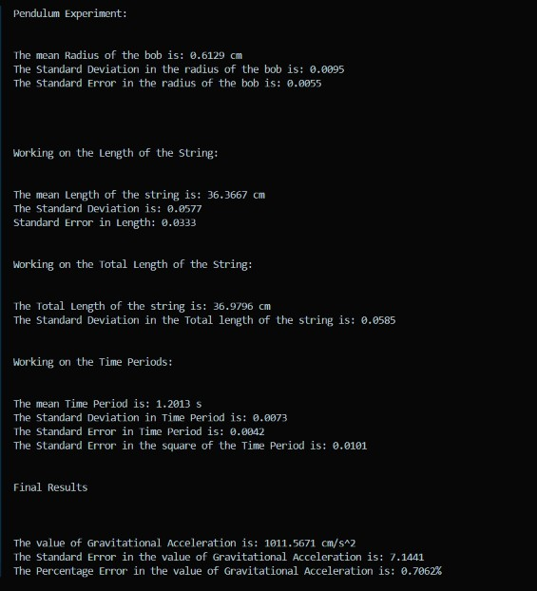
OUTPUT OF THE CODE

